Exploration of the Computational Theory of Mind
Through Visual Perception and Sequential circuits

Stella Pan
GitHub Repository: https://github.com/superstelli0311/Philos-133-Project-Combinatorial-Sequential-Circuit-Simulator

Introduction
How do we maneuver in space we live in without bumping into walls, or recognize a friend as they walk toward us? Visual perception is arguably the most important cognitive process for individuals with the capacity for sight, yet it’s often taken for granted. From edge detection to the perception of movement, depth, and even visual illusions, the brain carries out a wide range of operations, integrating lower-level neural activity with higher-level influences from prior knowledge. In this essay, I will examine perception through the framework of the Computational Theory of Mind and its computational levels as proposed by Fodor and Marr, using sequential circuits and accompanying code to demonstrate implementation-level visual representations, as well as evaluating the constraints of the CTM approach.
The Computational Theory of Mind resides in the functionalist school of thought, the belief that mental states are defined by their functions rather than their physical composition. This theory focuses on the mind’s role in receiving input, manipulating it, and propagating it through one’s physical body to produce a desired output. A core argument of functionalism is multiple realizability, the idea that a single mental state could be realized by multiple physical states (Bickel, 2020). An analogy being that the mind is “ software, " and the brain is “ hardware, " and varied configurations of the “hardware” could produce the same functionality in the “software”. This proposition opens up the possibility that inanimate machines could embody or simulate (though which of the two is still highly debated) the same mental states that humans have.
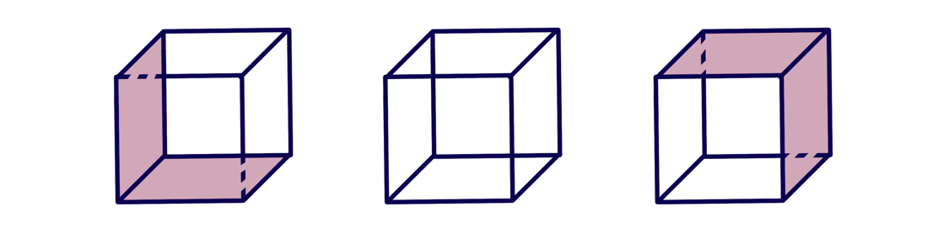
CTM expands on the complementary side of this idea by understanding the mind as a computational system, elucidating how cognitive states can emerge from the organized mechanical processes of the brain. Marr proposes three levels within this mechanism that was later classified into modules by Fodor. This includes the computational level, where the problem is described in abstract terms, detailing the goal of the computation and its strategy of implementation; this level is captured in semantic explanations of problems. Then, the representation and algorithm level suggest how the computational theory could be implemented, specifying the representation for the input and output. Lastly, the hardware implementation level explains how the algorithm can be realized physically, demonstrated using logic gates and sequential circuits in this essay. Although these three levels are logically related, Marr highlights that they are not mutually exclusive; some processes can be explained by more than one level (Marr, 2010). For example, the ambiguous perception of the Necker cube can be explained at the computational and representational levels, as a bistable neural network allows a 2D image to be perceived as 3D (Figure 1).
Figure 1: Necker Cube Illusion
Marr’s three levels serve as a fitting method to examine the complexities of the mind as a computational system, especially regarding the topic of perception. Vision involves defining structured problems, abstraction of representation, and concrete physical implementations. It is a well-defined and layered system that is ideal for exploring and assessing the strength and limitations of the Computational Theory of Mind.

Visual Perception
According to Marr’s computational model of vision, perception is composed of a sequence of information processing stages that transforms retinal activation into a detailed structural description of our object’s environment. From a computational level, vision enables us to interact with our surrounding, aiding our survival and procreation from an evolutionary standpoint. From an algorithmic level, the visual system constructs a series of representations that retrieves and analyzes visual features. The primal sketch receives information form the raw image and captures basic features like zero crossing, edges, and blobs. Then the 2 ½ sketch is formed, encoding the local surface orientations and depth values. Finally, information about these features is consolidated into a 3D model representation that is organized hierarchically in a viewpoint dependent manner. From an implementational level, neural circuits propagate information about shape and form through regions of our brain responsible for vision (Marr, 2010).
Later, Fodor utilized this example as a clear demonstration of his theory that the mind is composed of a collection of modules. Each module takes in input, computes a function, and produces an output that becomes available to other modules. Their ability to encapsulate information is a key feature in constructing computational mechanisms, meaning that each module can only access a limited subset of information within the system, especially with respect to memory. Another integral characteristic is that modules are domain-specific, meaning that they perform highly specialized functions (e.g., depth detection and color analysis are discrete and independent). The concepts of modularity and CTM are intricately linked, as both emphasize the subdivision of complex cognitive systems into specialized, subordinate components. They also reflect an evolutionary optimization of information processing. The division of modules enables mental processes to occur simultaneously, thereby increasing efficiency. Additionally, the encapsulation of information reduces the amount of content each module must store and compute again (Deroy, 2015).
In a sense, a sequential circuit functions as a base-level module. It performs a transformation on an input and produces an output that can be integrated into higher-order modules. Each circuit can access only the information stored in its local memory box, and each carries out a specific function. In the following section, I will demonstrate how sequential circuits can be used to detect changes in visual inputs, vertical movement, and depth, thereby illustrating the implementation level within Marr’s computational theory of vision.

Sequential Circuit Implementation
Pygame Circuit Stimulator
In order to provide a convenient way of visualizing and authenticating the circuits I will be constructing, as well as to offer a distributable virtual application for future students who are exploring combinatorial and sequential circuits and want to perceive its mechanisms at work but do not have access to physical materials, I wrote a program that can let users build their own circuit by connecting a combination of input, logic gate, memory, and output blocks using “wires.” This program and user instructions are contained in an executable file in the GitHub repository linked on the title page, along with the Python code with detailed comments for those who are interested in understanding the mechanisms under the hood. I will provide a high-level explanation of the process of its creation and its functionalities.
I created a toolbox where users can toggle blocks to spawn the corresponding gates on the gridded workspace, which allows the snapping of blocks and wires for clean visualization. Each block contains input and output port(s), which can be connected with wires by dragging from an output port to propagate the Boolean signal from one block to the next. The color of the wire indicates which signal is being propagated: green for 1 and red for 0. If the wire does not touch the input port of the proceeding block, it disappears. To improve program flexibility, users can delete blocks and wires with a right click. If a block is deleted, all its connected wires are deleted as well to ensure that there is no leftover signal path.
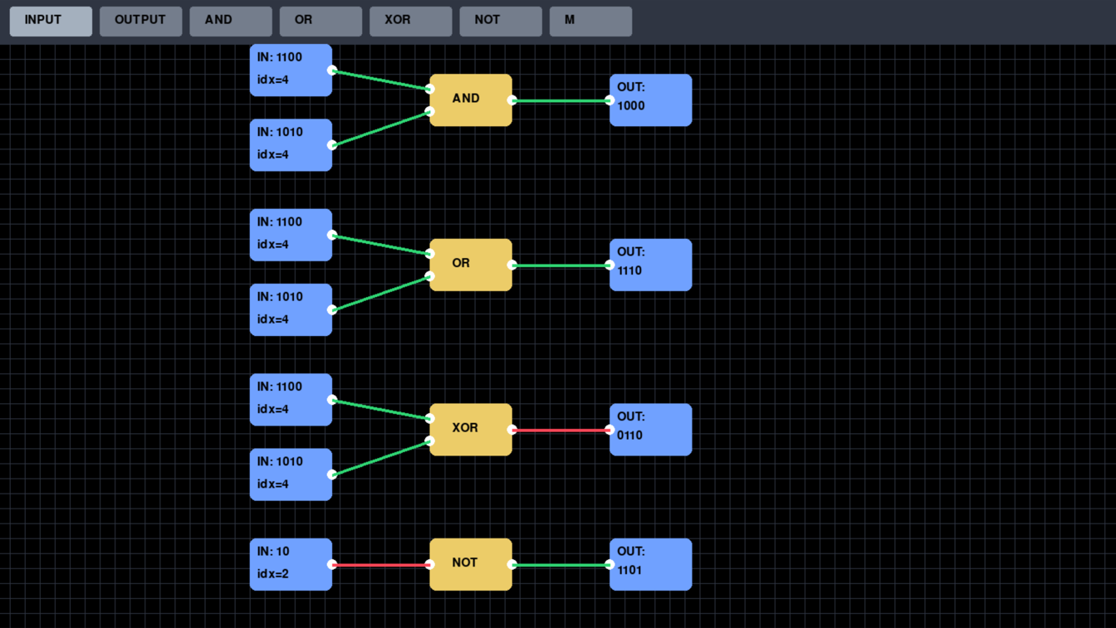
The input block will allow user inputs by clicking on it and typing 1s or 0s (nothing will appear if other keys are pressed). Theoretically, it takes an unlimited number of bits as input like that of a sequential circuit; it is only limited by the display space and your computer’s storage capacity. When only given one bit as input, one can assume that it functions like a combinatorial circuit. Additionally, you can modify your input by typing backspace and pressing Enter signifies exiting typing mode. Both the bits in the input and the output are displayed Most Significant Bit first spatially, akin to how we normally read digits. However, the Least Significant Bit of the input is sent through the circuit and displayed in output first to imitate the process of each bit being propagated through the circuit for each clock cycle. This is achieved by indexing each string of bits backwards in the input block and appending each bit to the left of the previous output in the output block.
Figure 2: Logic Gates Demo
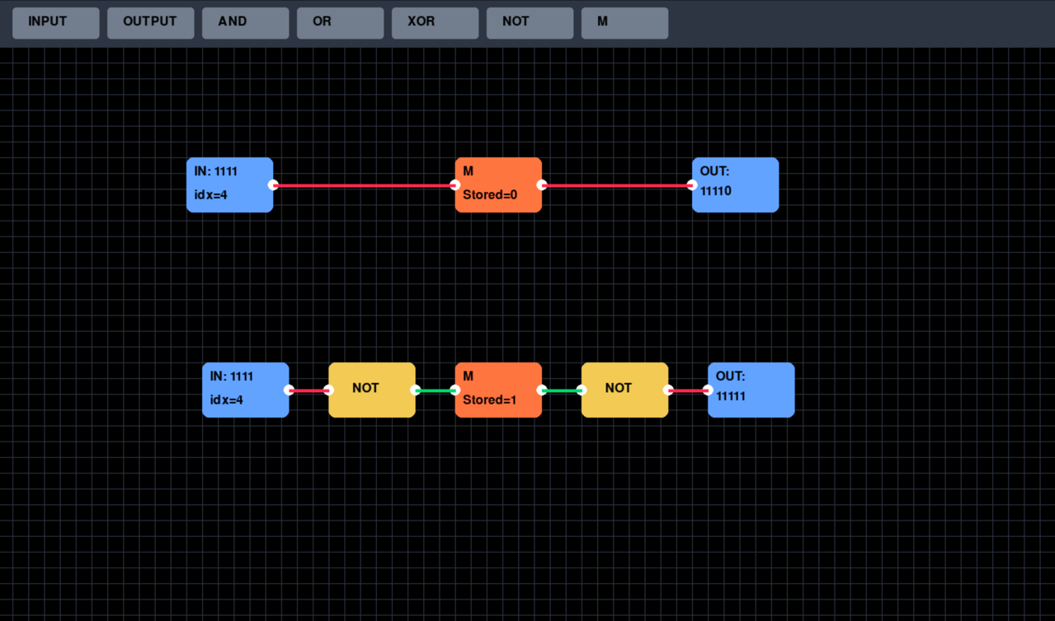
The implemented logic gates are tested in Figure 2. The underlying computations are carried out using built-in Python functions: all () for AND, any () for OR, and not for NOT. For the XOR gate, I approached the logic from a functional standpoint and programmed it to output 1 whenever the two inputs differ. To ensure accuracy, I tested all possible combinations of inputs for each logic gate. To initiate each clock cycle, the user presses the Space key, which increments the index counter at the bottom of all input blocks simultaneously to document the number of bits being passed through the wire. The color of the wires will update for each clock cycle to reflect real time changes in the signal being passed. When all inputs are exhausted, the input bit defaults to 0. This is demonstrated by the last two outputs of the NOT gate being 1.
Figure 3: Memory Block Demo
Given that there are no built-in Python functions that imitate a flip-flop, the creation of a memory block (Figure 3) is a more complicated process. As implementing it directly using logic gates would be both complex and unnecessary in this context, I instead approached it from a higher level of abstraction. I created three functions within the memory block class: one that outputs the stored bit (initially 0), one that captures the next M-in, and one that stores the M-in for the next clock cycle (as shown in the M block). These functions are executed in sequence when each cycle is initiated. Because all wire to propagate simultaneously without regards to order, to ensure the stability of each constructed circuit, the logic gates before and after the memory block are ran multiple times until their outputs remains constant. Figure 3 authenticates that the memory block succeeds in computing +1 in tally and ×2 in binary.
Now that the functionalities of the program are clarified, we can now apply it to visual perception problems.

Solving Perception Problems:
Assume our visual field is represented by a sequential circuit that has 8 inputs blocks on a single axis, top four for our right visual field and bottom four for our left visual field. The bits in each input block signifies an array of stimulations, and their output corresponds to a specific action being detected.
- Change Detection
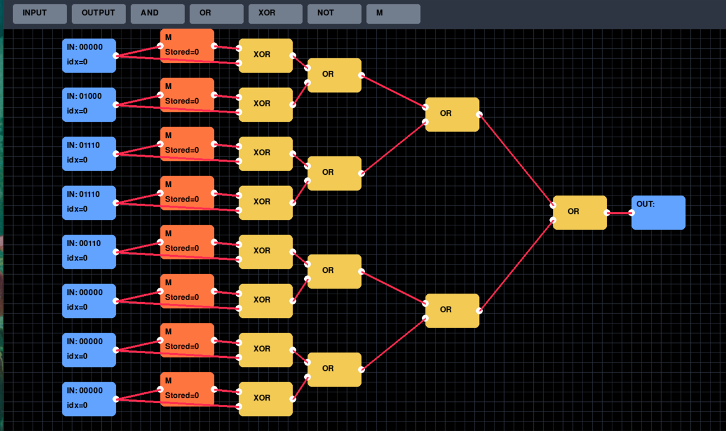
The first problem we will be solving is change detection, a fundamental mechanism of our vision. It brings our attention to novel information, which is integral in learning new stimuli in the environment and adapting accordingly. On an algorithmic level, we detect changes by comparing the previous visual input with the current visual input. Thus, the circuit will output 1 if and only if the current input differs in any way form the precious input 1, signifying that a change has been detected.
Figure 4: Change Detector Initial State
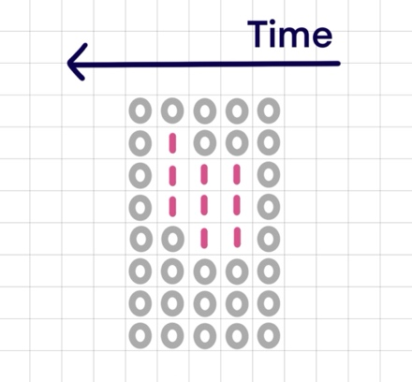
To compare each input with the previous one, we need to store each input in M and put both the new and old input through an XOR, which will deliver a 1 to its output port if they are different. By connecting the XOR gates with OR gates, the output will become 1 if any of the input’s changes.
Figure 5: Change Detector Input
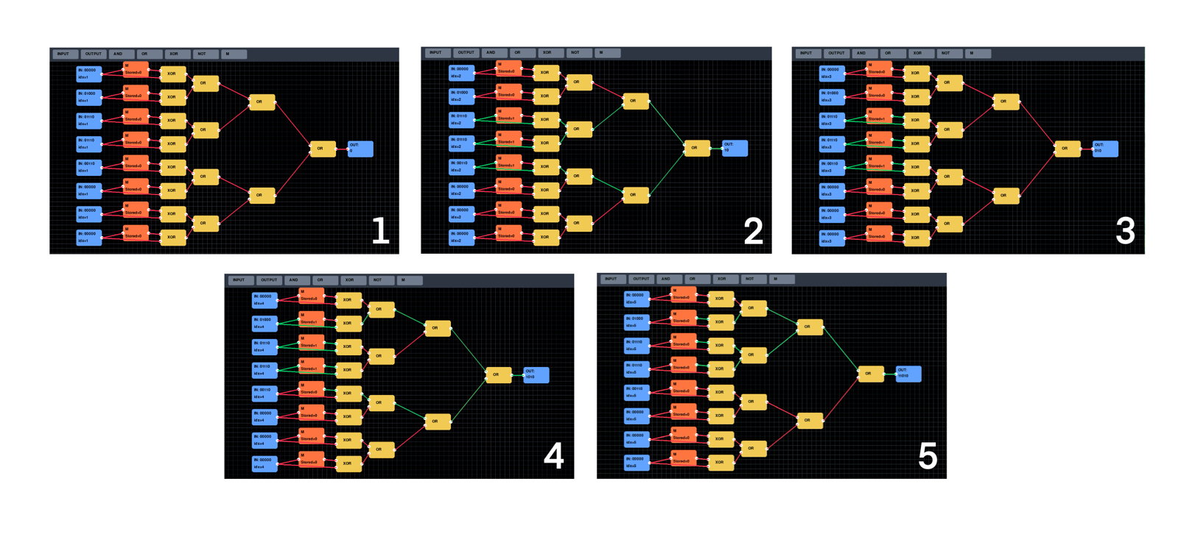
The input is defined above, providing a clear visualization of a changing visual field. According to this, the output should be 11010. As the visual field differs from the previous in the second, fourth, and fifth round of input (counting from right to left).
Figure 6: Change Detector All States
Figure 6 shows the clock cycles and the changes in each wire’s signal at every step, confirming the final output of 11010.
- Motion detection
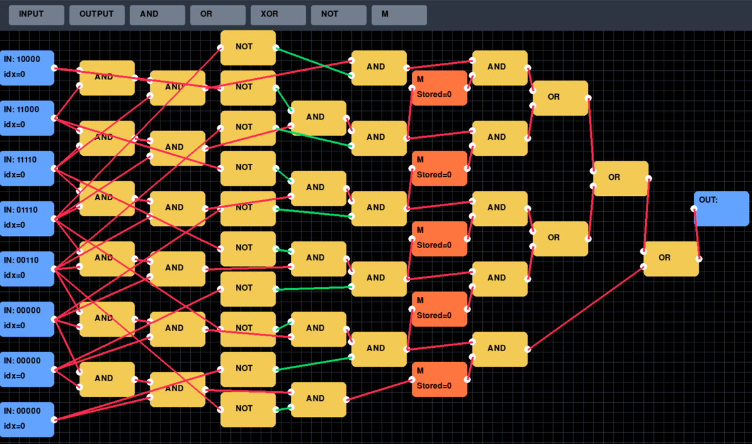
To advance upon the change detector, we will implement the motion detector next. This allows us to differentiate the movement of objects from a static background, aiding the extraction of relevant figures in scenes that might otherwise remain ambiguous. Assume that an object is defined as a string of exactly three consecutive 1s. The circuit will output 1 if and only if there is an object image anywhere in the input moving rightward 1 unit per clock cycle.
Figure 7: Motion Detector Initial State
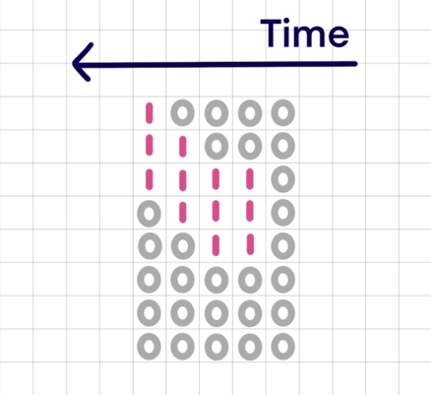
To compare the positions of the object, we need to store their previous position in M and pass it though AND gates with our current position (one block rightwards), if both positions are activated, it means an object moved upwards from its previous position to current position. There are five M blocks for five different combinations of 3 consecutive inputs possible, each representing a potential position for the object to be in.
Figure 8: Motion Detector Input
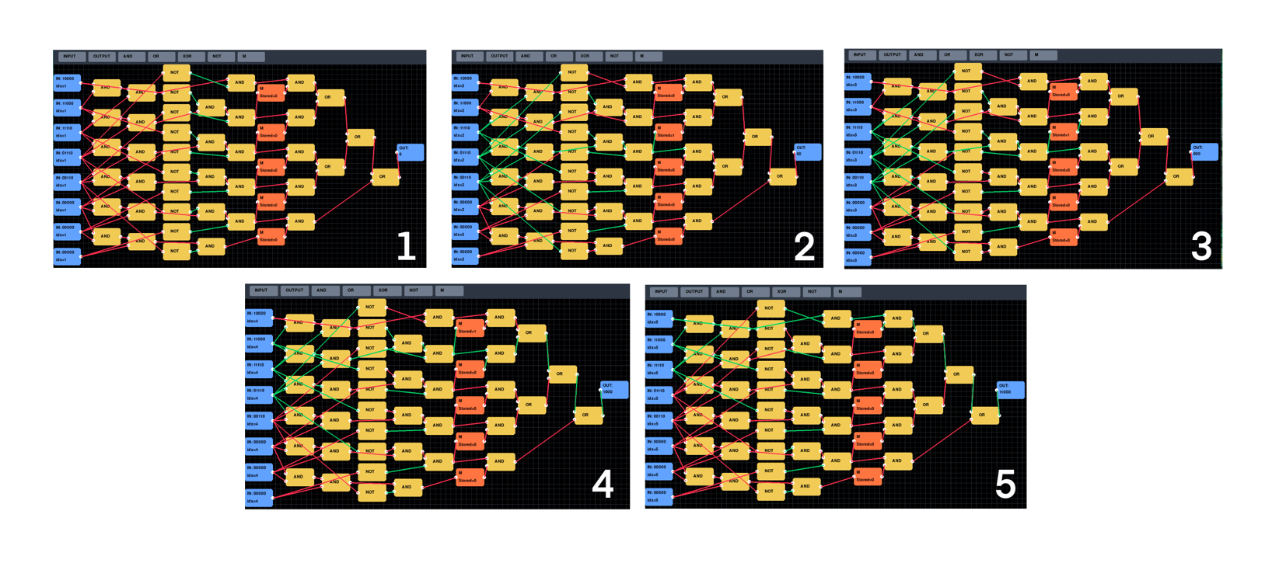
The input is defined above. The predicted output should be 11000, as the only showcased movement is from the third round of input to the fourth and the fourth round of input to the fifth.
Figure 9: Motion Detector All States
Figure 9 shows the clock cycles and the changes in each wire’s signal at every step, confirming the final output of 11000.
- Depth detection
Lastly, we progress into depth perception. It allows us to judge the distance of objects relative to ourselves and to interpret the spatial layout of our surroundings. This guides our navigation through the world and enables rapid decisions, including fight or flight responses that are integral to survival. As depth perception is a complex process within the 2½-D stage of Marr’s computational model of vision, sequential circuits cannot capture the range of functions that contribute to it, such as binocular disparity or motion parallax. Thus, the demonstration here will be a highly simplified version of depth perception, essentially a detector for motion that is perpendicular to our visual field.
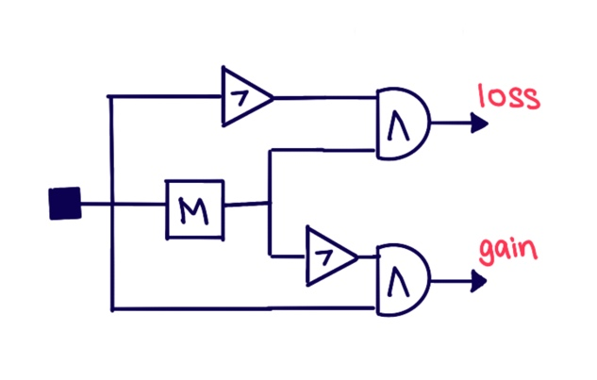
Assume that an object is composed of consecutive inputs and is centered in your visual field, so the left and right sides mirror each other. The circuit will output 1 if and only if the object is approaching you (computational level), meaning it occupies more of your visual field than in the previous clock cycle (algorithmic level), which is reflected in more 1s appearing in both the left and right halves of input blocks (implementational level).
Figure 10: Gain/Loss Detector
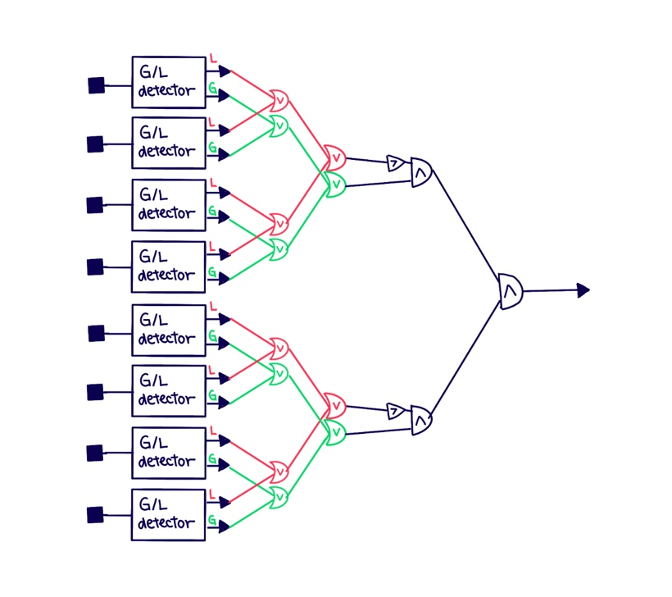
I will dive more deeply into the process of solving this problem, since it has not appeared previously in this course. First, we need to detect if each bit in each input block changes from the previous input bit. To do this, we store each previous bit in M and compare it to the current bit. If previous bit is 0 and current bit is 1, that signifies a gain, if previous bit is 1 and current bit is 0, that signifies a loss. This gain/loss detector is illustrated above.
Figure 11: Depth Detector Outline
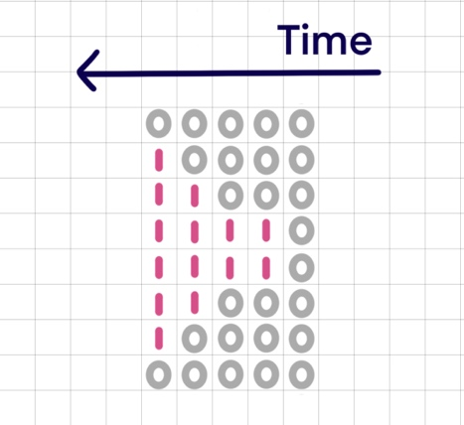
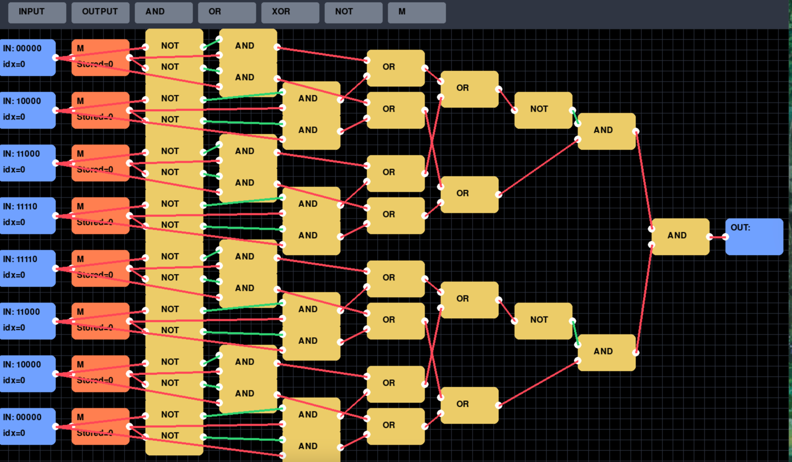
To compute change in depth, each input block needs to be passed through gain/loss detector. All local loss outputs are propagated through a set OR gates and a negation, while all local gain outputs are propagated through separate set of OR gates. Thus, the output will be 1 if and only if there are gains and no losses on both sides of the visual field. A more organized illustration is displayed as Figure 11. Below is the program implementation of the circuit.
Figure 12: Depth Detector Input
Figure 13: Depth Detector
The input is defined above. The predicted output should be 11010, as the object appears in the second round of input and grows in the fourth and fifth rounds, indicating that it is approaching us.

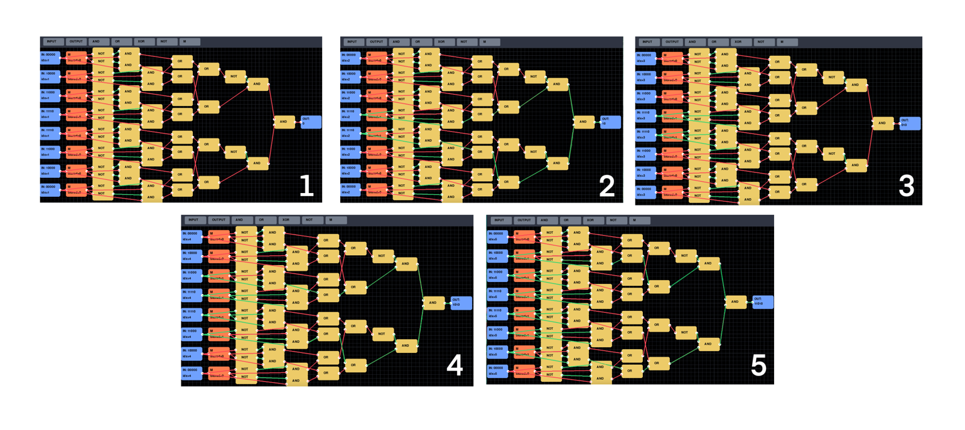
Figure 14 shows the clock cycles and the changes in each wire’s signal at every step, confirming the final output of 11010.
Figure 14: Depth Detection All States

Limitations to Modular and Computational approach to Vision
Although the demonstrations above show that basic modules can be implemented through computational logic to represent certain components of vision, there remains a wide range of phenomena that the modular theory of vision does not account for. Studies have suggested that prior expectations or emotions have the ability to shape perception. In the New Look experiment, the objects known to be a certain color are matched with a more saturated red background than other items, signifying that our predisposition to red objects throughout our lives has led us to have a skewed perception of their intensity of red. This challenges the cognitive impenetrability of modular vision. Moreover, multisensory perception shows that the brain can integrate information horizontally, rather than relying purely on top-down or bottom-up processing. This is evident in the McGurk effect, where auditory information (the sound “gaga”) is influenced by visual information (a mouth producing “baba”), and the two stimuli occurring close in time generate the illusory perception of “dada.” This phenomenon calls into question the independence of perceptual modules (Deroy, 2015). Despite its limitations, the Computational Theory of Mind still serves as a useful entryway model for understanding fundamental perceptual functions within lower levels of cognition.
Works Cited
Bickle, J. (2020). Multiple realizability. In E. N. Zalta (Ed.), The Stanford encyclopedia of philosophy (Summer 2020 ed.). Stanford University. https://plato.stanford.edu/archives/sum2020/entries/multiple-realizability/
Deroy, O. (2015). Modularity of perception. In M. Matthen (Ed.), The Oxford handbook of philosophy of perception. Oxford University Press. https://doi.org/10.1093/oxfordhb/9780199600472.013.028
Fodor, J. A. (1983). The Modularity of Mind. The MIT Press. https://doi.org/10.7551/mitpress/4737.001.0001
Greenberg, Gabriel. (2025). Making Minds: A Constructive Introduction to the Computational Theory of Mind
Marr, D. (2010). Vision: A computational investigation into the human representation and processing of visual information. The MIT Press. https://doi.org/10.7551/mitpress/9780262514620.001.0001
Pygame Developers. (n.d.). Pygame documentation. Retrieved from https://www.pygame.org/docs/
Rescorla, M. (2025). The computational theory of mind. In E. N. Zalta & U. Nodelman (Eds.), The Stanford encyclopedia of philosophy (Fall 2025 ed.). Stanford University. https://plato.stanford.edu/archives/fall2025/entries/computational-mind/

